Name: Jing Ma

ECE 118 Lab 2

#include "library.h"

//Part 1//

/*

void draw_star(int const length){

//length is the length of each if the ten lines that make up the star

set_pen_width(5);

set_heading_degrees(90);

draw_distance(length);

turn_left_by_degrees(72);

draw_distance(length);

turn_right_by_degrees(144);

draw_distance(length);

turn_left_by_degrees(72);

draw_distance(length);

turn_right_by_degrees(144);

draw_distance(length);

turn_left_by_degrees(72);

draw_distance(length);

turn_right_by_degrees(144);

draw_distance(length);

turn_left_by_degrees(72);

draw_distance(length);

turn_right_by_degrees(144);

draw_distance(length);

turn_left_by_degrees(72);

draw_distance(length);

}

void main(){

make_window(500,500);

move_to(140,150);

draw_star(100);

}

*/

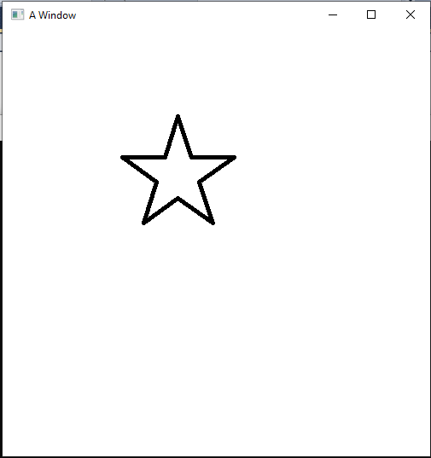

//Part 2//

/*

void draw_star(int const length){

//length is the length of each if the ten lines that make up the star

start_shape();

set_pen_width(5);

set_heading_degrees(90);

draw_distance(length);

turn_left_by_degrees(72);

draw_distance(length);

turn_right_by_degrees(144);

draw_distance(length);

turn_left_by_degrees(72);

draw_distance(length);

turn_right_by_degrees(144);

draw_distance(length);

turn_left_by_degrees(72);

draw_distance(length);

turn_right_by_degrees(144);

draw_distance(length);

turn_left_by_degrees(72);

draw_distance(length);

turn_right_by_degrees(144);

draw_distance(length);

turn_left_by_degrees(72);

draw_distance(length);

}

void main(){

make_window(500,500);

move_to(140,150);

draw_star(50);

move_to(182,275);

draw_star(50);

move_to(318,275);

draw_star(50);

move_to(360, 150);

draw_star(50);

move_to(250, 70);

draw_star(50);

move_to(100, 300);

draw_star(30);

move_to(400, 400);

draw_star(20);

}

*/

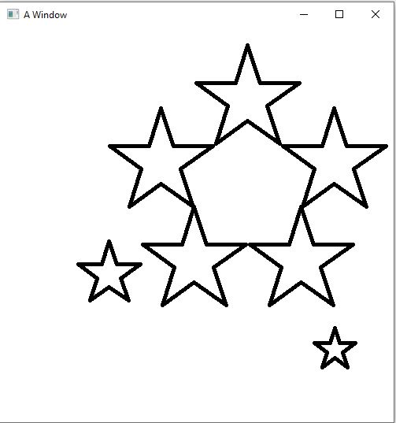

//Part 3 Couloring it in

/*

void draw_star(int const length){

//length is the length of each if the ten lines that make up the star

start_shape();

set_pen_width(5);

set_heading_degrees(90);

draw_distance(length); note_position();

turn_left_by_degrees(72);

draw_distance(length); note_position();

turn_right_by_degrees(144);

draw_distance(length); note_position();

turn_left_by_degrees(72);

draw_distance(length); note_position();

turn_right_by_degrees(144);

draw_distance(length); note_position();

turn_left_by_degrees(72);

draw_distance(length); note_position();

turn_right_by_degrees(144);

draw_distance(length); note_position();

turn_left_by_degrees(72);

draw_distance(length); note_position();

turn_right_by_degrees(144);

draw_distance(length); note_position();

turn_left_by_degrees(72);

draw_distance(length); note_position();

}

void main(){

make_window(500,500);

set_pen_color(color::blue);

move_to(140,150);

draw_star(100);

fill_shape();

}

*/

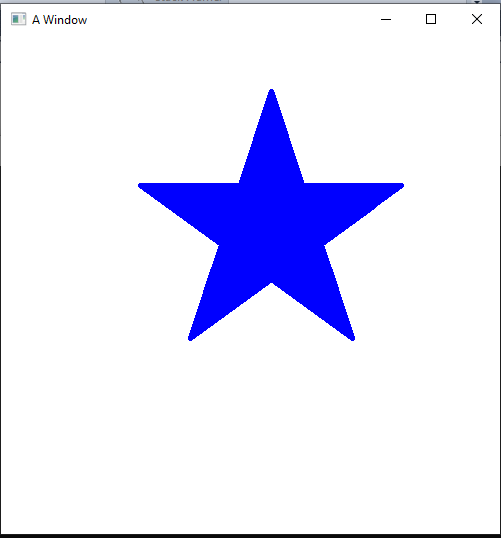

//Part 4 Lone-Star Program

/*

void draw_vertical_stripe(int const length, int const width){

//vertical stripe 100*200

start_shape();

set_pen_width(2);

set_heading_degrees(90);

draw_distance(length); note_position();

turn_left_by_degrees(90);

draw_distance(width); note_position();

turn_left_by_degrees(90);

draw_distance(length); note_position();

turn_left_by_degrees(90);

draw_distance(width); note_position();

}

void draw_horizontal_stripe(int const length, int const width){

//horizontal stripe 200*100

start_shape();

set_pen_width(2);

set_heading_degrees(90);

draw_distance(length); note_position();

turn_left_by_degrees(90);

draw_distance(width); note_position();

turn_left_by_degrees(90);

draw_distance(length); note_position();

turn_left_by_degrees(90);

draw_distance(width); note_position();

}

void draw_lone_star(int const length) {

start_shape();

set_pen_width(2);

set_heading_degrees(90);

draw_distance(length); note_position();

turn_left_by_degrees(72);

draw_distance(length); note_position();

turn_right_by_degrees(144);

draw_distance(length); note_position();

turn_left_by_degrees(72);

draw_distance(length); note_position();

turn_right_by_degrees(144);

draw_distance(length); note_position();

turn_left_by_degrees(72);

draw_distance(length); note_position();

turn_right_by_degrees(144);

draw_distance(length); note_position();

turn_left_by_degrees(72);

draw_distance(length); note_position();

turn_right_by_degrees(144);

draw_distance(length); note_position();

turn_left_by_degrees(72);

draw_distance(length); note_position();

set_pen_color(color::white);

fill_shape();

}

void main(){

make_window(300,200);

set_pen_color(color::blue);

move_to(0,200);

draw_vertical_stripe(100,200);

fill_shape();

set_pen_color(color::red);

move_to(102,200);

draw_horizontal_stripe(200,100);

fill_shape();

move_to(10,80);

draw_lone_star(30);

}

*/

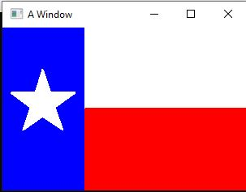

//Part 5 Row of Star

/*

void draw_star(double const length){

//length is the length of each if the ten lines that make up the star

start_shape();

set_pen_width(1);

set_heading_degrees(162);

set_pen_color(color::white);

draw_distance(length); note_position();

turn_left_by_degrees(72);

draw_distance(length); note_position();

turn_right_by_degrees(144);

draw_distance(length); note_position();

turn_left_by_degrees(72);

draw_distance(length); note_position();

turn_right_by_degrees(144);

draw_distance(length); note_position();

turn_left_by_degrees(72);

draw_distance(length); note_position();

turn_right_by_degrees(144);

draw_distance(length); note_position();

turn_left_by_degrees(72);

draw_distance(length); note_position();

turn_right_by_degrees(144);

draw_distance(length); note_position();

turn_left_by_degrees(72);

draw_distance(length); note_position();

fill_shape();

}

void row_of_six_stars(double const size, double const length, double const line)

{

double side = (.809 * (.06*length)/2);

double spacing = (.033 * size);

move_to(spacing, ((.054*length*line)-((side/.809))));

draw_star(side);

move_to(3*spacing, ((.054*length*line)-((side/.809))));

draw_star(side);

move_to(5*spacing, ((.054*length*line)-((side/.809))));

draw_star(side);

move_to(7*spacing, ((.054*length*line)-((side/.809))));

draw_star(side);

move_to(9*spacing, ((.054*length*line)-((side/.809))));

draw_star(side);

move_to(11*spacing, ((.054*length*line)-((side/.809))));

draw_star(side);

}

void row_of_five_stars(double const size, double const length, double const line)

{

double side = (.809*(.06*length)/2);

double spacing = (.033*size*2);

move_to(spacing, (.054*length*line)-((side/.809)));

draw_star(side);

move_to(2 * spacing, (.054*length*line)-((side/.809)));

draw_star(side);

move_to(3 * spacing, (.054*length*line)-((side/.809)));

draw_star(side);

move_to(4 * spacing, (.054*length*line)-((side/.809)));

draw_star(side);

move_to(5 * spacing, (.054*length*line)-((side/.809)));

draw_star(side);

}

void main(){

const double height = 200;

const double width = 2.0*height;

make_window(width, height);

set_pen_color(color::dark_blue);

fill_rectangle(0.0, 0.0, (0.4*width), (0.5385*height));

move_to((0.063*width), (0.027*height));

set_pen_color(color::white);

//row_of_six_stars(width, height, 1);

row_of_five_stars(width, height, 1);

}

*/





//Part 6

/*

void draw_star(double const length){

//length is the length of each if the ten lines that make up the star

start_shape();

set_pen_width(1);

set_heading_degrees(162);

set_pen_color(color::white);

draw_distance(length); note_position();

turn_left_by_degrees(72);

draw_distance(length); note_position();

turn_right_by_degrees(144);

draw_distance(length); note_position();

turn_left_by_degrees(72);

draw_distance(length); note_position();

turn_right_by_degrees(144);

draw_distance(length); note_position();

turn_left_by_degrees(72);

draw_distance(length); note_position();

turn_right_by_degrees(144);

draw_distance(length); note_position();

turn_left_by_degrees(72);

draw_distance(length); note_position();

turn_right_by_degrees(144);

draw_distance(length); note_position();

turn_left_by_degrees(72);

draw_distance(length); note_position();

fill_shape();

}

void row_of_six_stars(double const size, double const length, double const line)

{

double side = (.809 * (.06*length)/2);

double spacing = (.033 * size);

move_to(spacing, ((.054*length*line)-((side/.809))));

draw_star(side);

move_to(3*spacing, ((.054*length*line)-((side/.809))));

draw_star(side);

move_to(5*spacing, ((.054*length*line)-((side/.809))));

draw_star(side);

move_to(7*spacing, ((.054*length*line)-((side/.809))));

draw_star(side);

move_to(9*spacing, ((.054*length*line)-((side/.809))));

draw_star(side);

move_to(11*spacing, ((.054*length*line)-((side/.809))));

draw_star(side);

}

void row_of_five_stars(double const size, double const length, double const line)

{

double side = (.809*(.06*length)/2);

double spacing = (.033*size*2);

move_to(spacing, (.054*length*line)-((side/.809)));

draw_star(side);

move_to(2 * spacing, (.054*length*line)-((side/.809)));

draw_star(side);

move_to(3 * spacing, (.054*length*line)-((side/.809)));

draw_star(side);

move_to(4 * spacing, (.054*length*line)-((side/.809)));

draw_star(side);

move_to(5 * spacing, (.054*length*line)-((side/.809)));

draw_star(side);

}

void main(){

const double height = 200;

const double width = 2.0*height;

make_window(width, height);

set_pen_color(color::dark_blue);

fill_rectangle(0.0, 0.0, (0.4*width), (0.5385*height));

move_to((0.063*width), (0.027*height));

set_pen_color(color::white);

row_of_six_stars(width, height, 1);

row_of_five_stars(width, height, 2);

}

*/



//Part 7 The American Flag

/*

void draw_star( double const length)

{

start_shape();

set_pen_width(1);

set_heading_degrees(162);

set_pen_color(color::white);

draw_distance(length); note_position();

turn_left_by_degrees(72);

draw_distance(length); note_position();

turn_right_by_degrees(144);

draw_distance(length); note_position();

turn_left_by_degrees(72);

draw_distance(length); note_position();

turn_right_by_degrees(144);

draw_distance(length); note_position();

turn_left_by_degrees(72);

draw_distance(length); note_position();

turn_right_by_degrees(144);

draw_distance(length); note_position();

turn_left_by_degrees(72);

draw_distance(length); note_position();

turn_right_by_degrees(144);

draw_distance(length); note_position();

turn_left_by_degrees(72);

draw_distance(length); note_position();

fill_shape();

}

void draw_stripes(double const width, double const height, int const a)

{

double const bar_height = (height/13);

if (a == 0)

{

set_pen_color(color::dark_red);

fill_rectangle(0.0, bar_height*a, width, bar_height);

}

else if (a % 2 == 1)

{

set_pen_color(color::white);

fill_rectangle(0.0, bar_height*a, width, bar_height);

draw_stripes(width, height, a-1);

}

else

{

set_pen_color(color::dark_red);

fill_rectangle(0.0, bar_height*a, width, bar_height);

draw_stripes(width, height, a-1);

}

}

void row_of_six_stars(double const size, double const length, double const line)

{

double side = (.809 * (.06*length)/2);

double spacing = (.033 * size);

move_to(spacing, ((.054*length*line)-((side/.809))));

draw_star(side);

move_to(3*spacing, ((.054*length*line)-((side/.809))));

draw_star(side);

move_to(5*spacing, ((.054*length*line)-((side/.809))));

draw_star(side);

move_to(7*spacing, ((.054*length*line)-((side/.809))));

draw_star(side);

move_to(9*spacing, ((.054*length*line)-((side/.809))));

draw_star(side);

move_to(11*spacing, ((.054*length*line)-((side/.809))));

draw_star(side);

}

void row_of_five_stars(double const size, double const length, double const line)

{

double side = (.809*(.06*length)/2);

double spacing = (.033*size*2);

move_to(spacing, (.054*length*line)-((side/.809)));

draw_star(side);

move_to(2 * spacing, (.054*length*line)-((side/.809)));

draw_star(side);

move_to(3 * spacing, (.054*length*line)-((side/.809)));

draw_star(side);

move_to(4 * spacing, (.054*length*line)-((side/.809)));

draw_star(side);

move_to(5 * spacing, (.054*length*line)-((side/.809)));

draw_star(side);

}

void main()

{

const double height = 800;

const double width = 2.0 * height;

const double stripeh = height/13.0;

make_window(width, height);

draw_stripes(width, height, 13);

set_pen_color(color::dark_blue);

fill_rectangle(0.0,0.0,(0.4*width), (.5385*height));

move_to((.063*width),(.027*height));

set_pen_color(color::white);

row_of_six_stars(width, height, 1);

row_of_five_stars(width, height, 2);

row_of_six_stars(width, height, 3);

row_of_five_stars(width, height, 4);

row_of_six_stars(width, height, 5);

row_of_five_stars(width, height, 6);

row_of_six_stars(width, height, 7);

row_of_five_stars(width, height, 8);

row_of_six_stars(width, height, 9);

}

*/

